**Basic Labs**

1. **EC2 Basics Lab**
   * **Objective**: To understand the process of setting up and managing an Amazon EC2 instance.
   * **Approach**: Students will start by launching a new EC2 instance, selecting an appropriate instance type and configuring the instance details. They will then create and configure a new Security Group, and allocate an Elastic IP address to the instance. The lab will also include connecting to the instance via SSH.
   * **Goal**: By the end of this lab, students should be able to launch and manage an EC2 instance, understand instance types, security groups, and IP addressing in AWS.
2. **Click on launch instances**

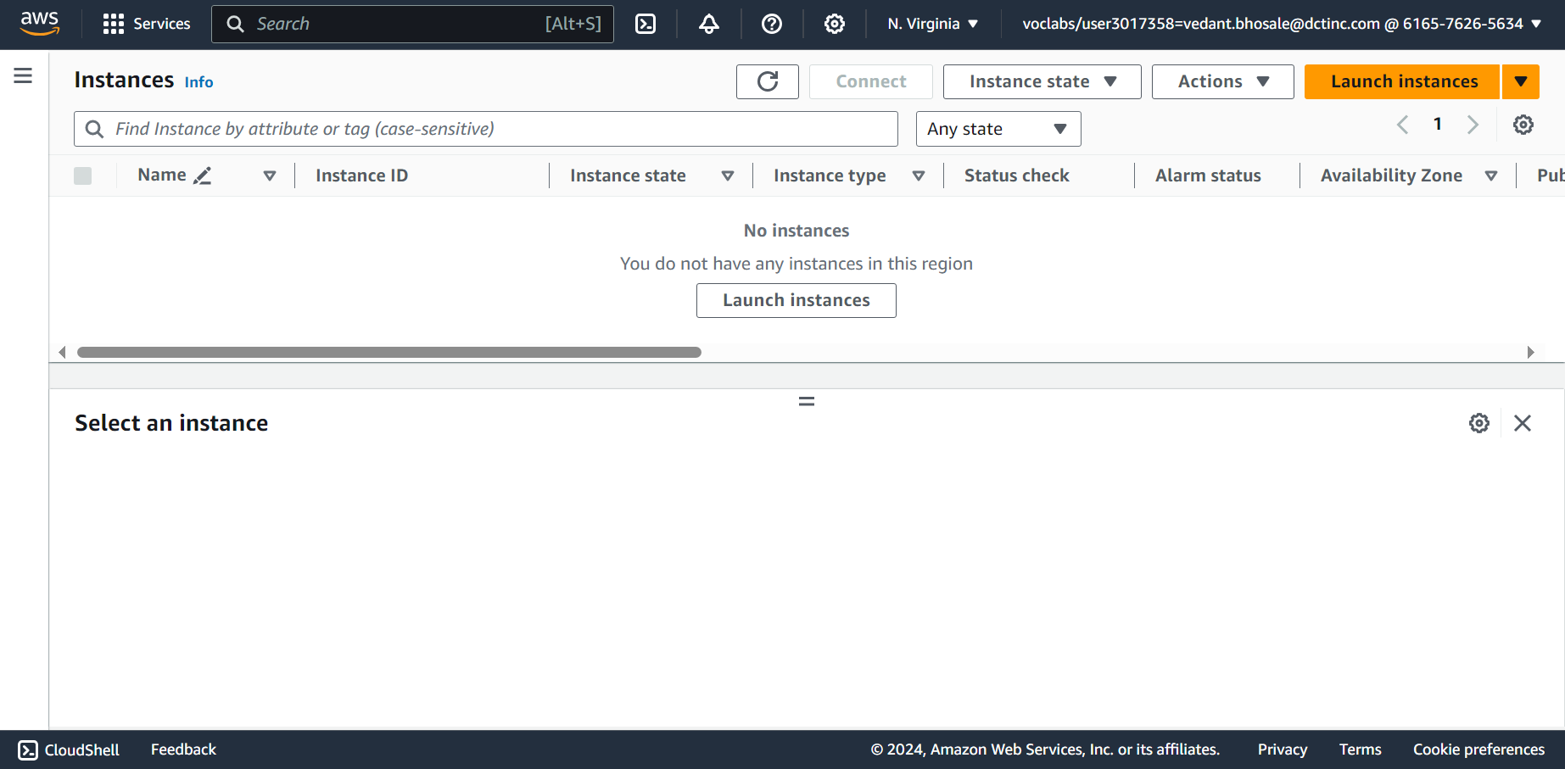

1. **Give name to the instance**

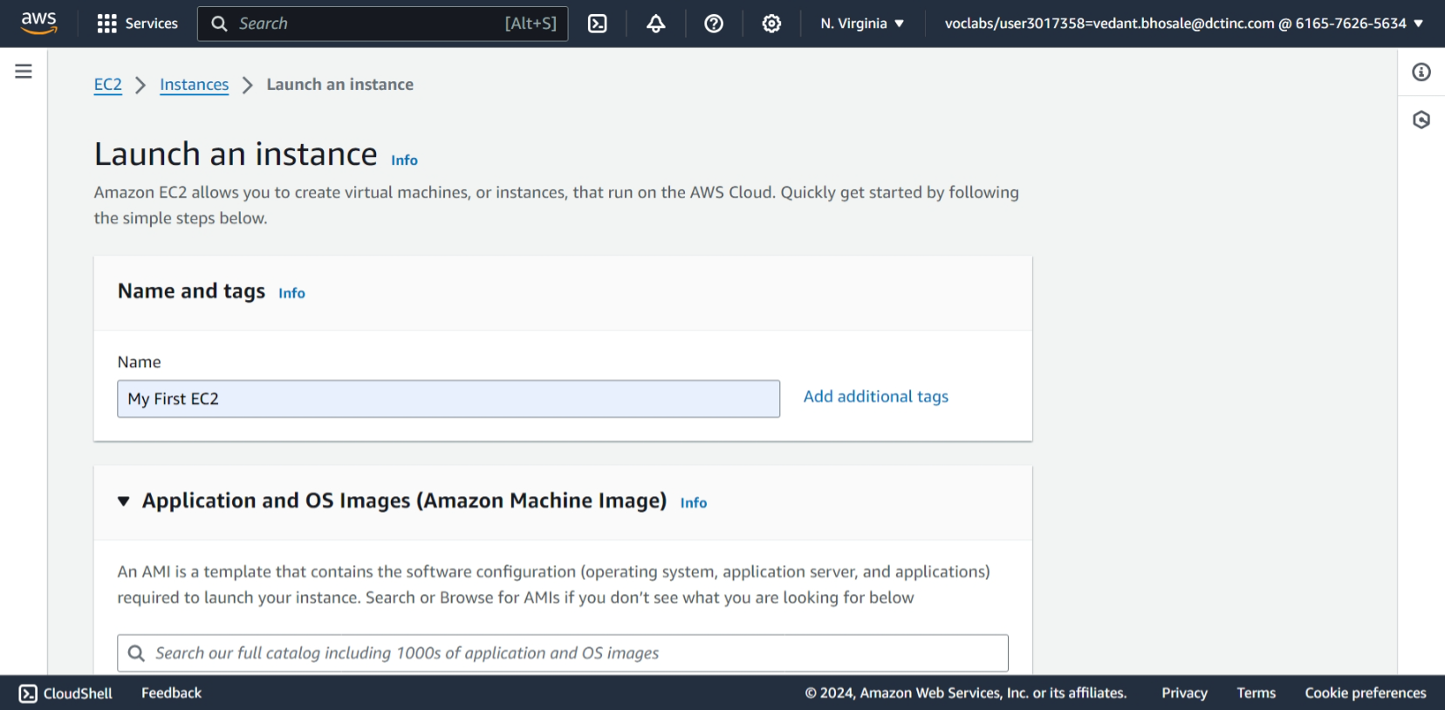

1. Select OS image for EC2
   * We select Amazon Linux

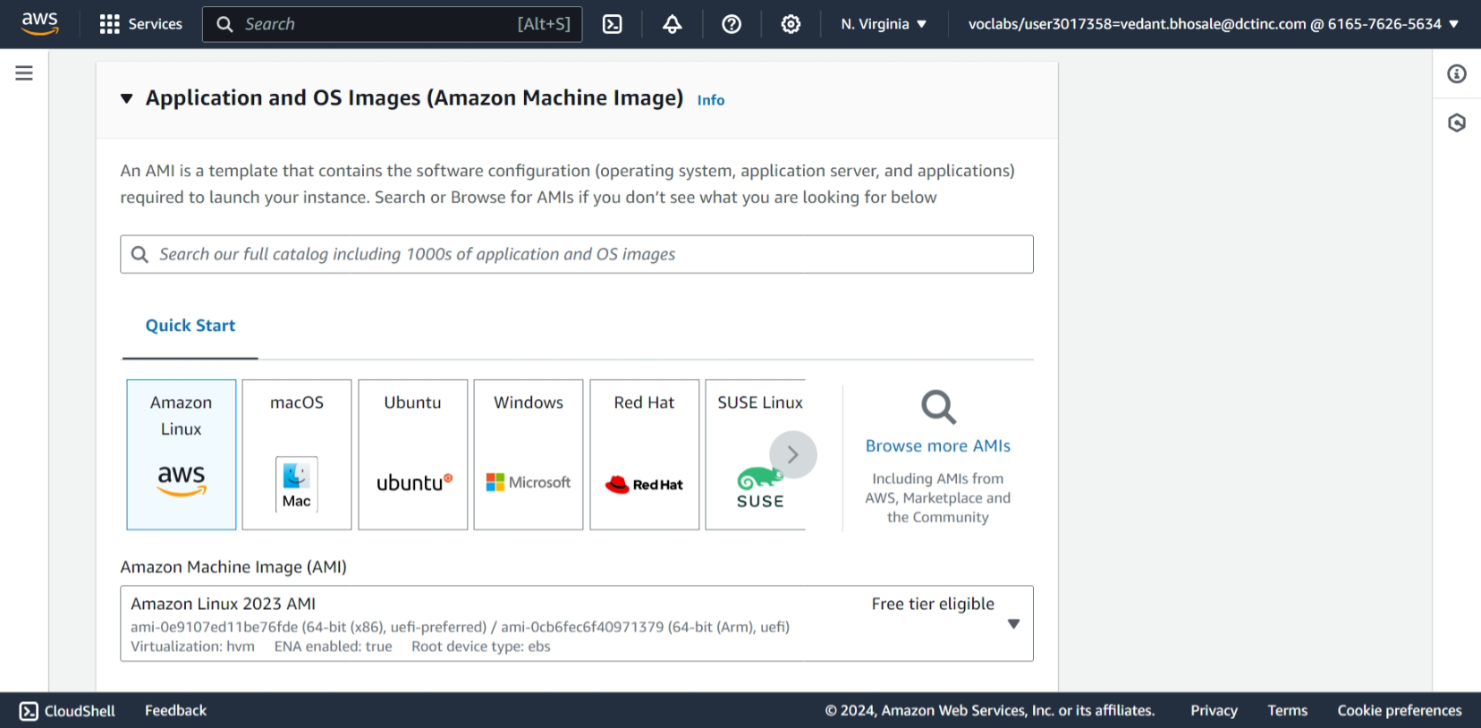

1. Create key pair
   * Give key pair name
   * Key pair type as RSA
   * Private key file format as .pem
   * Click on create key pair

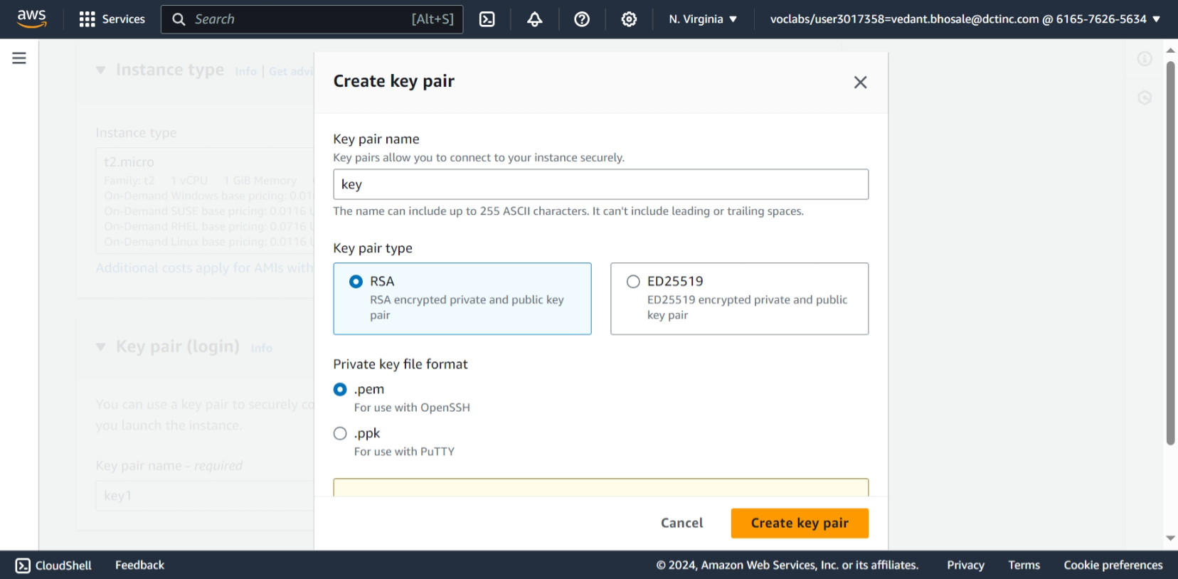

1. Create security group and edit the rules and create the instance

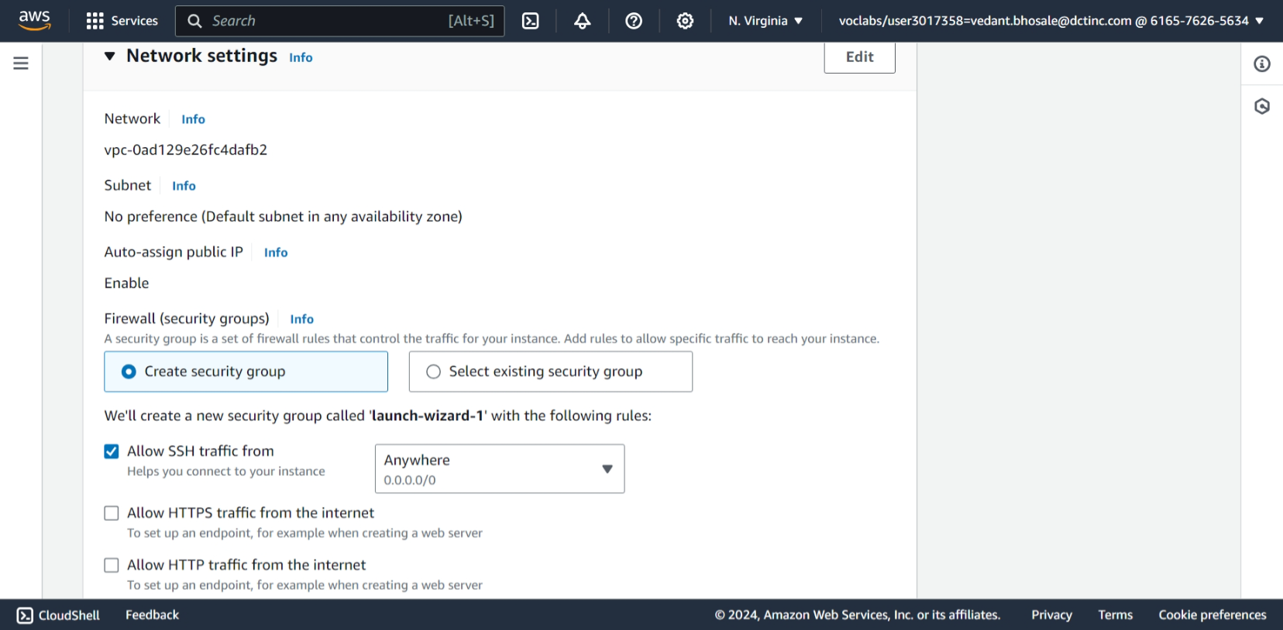

1. Here we see the created instance

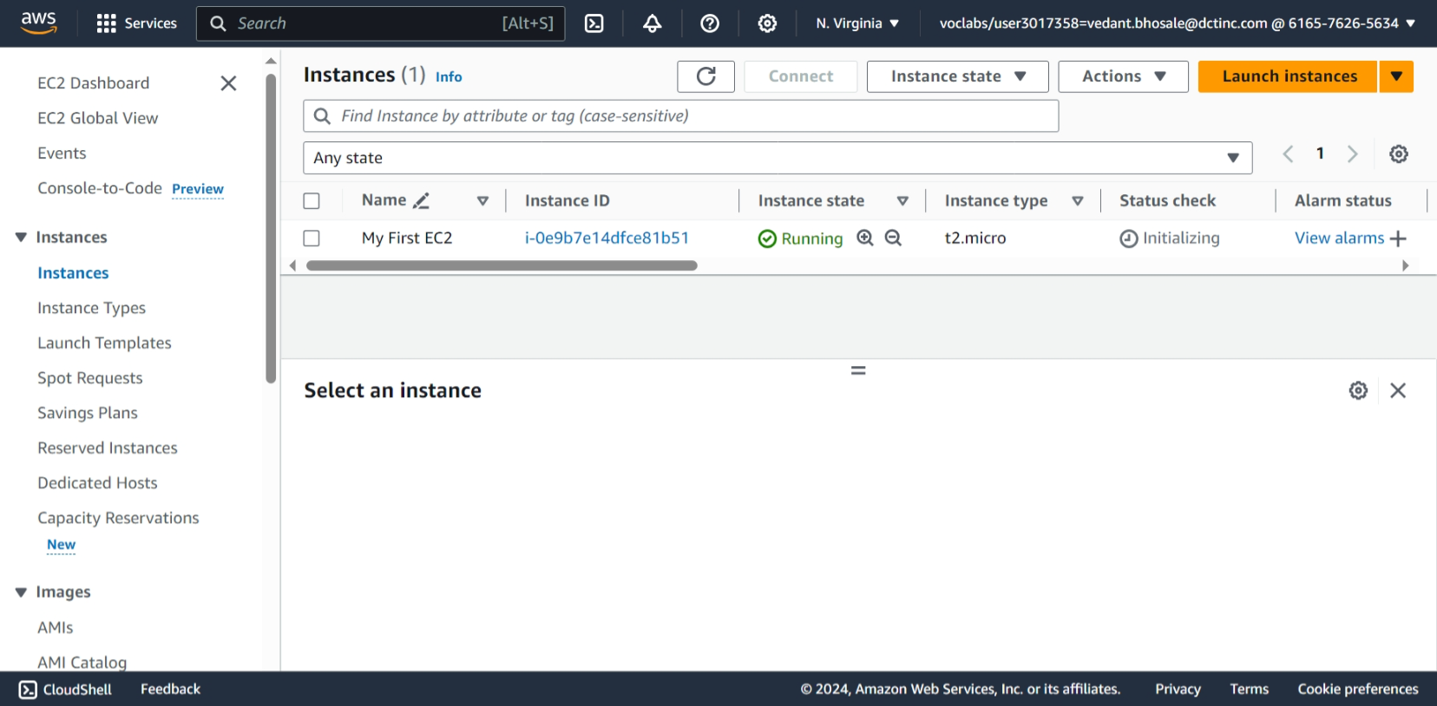

1. Allocating Elastic IP address

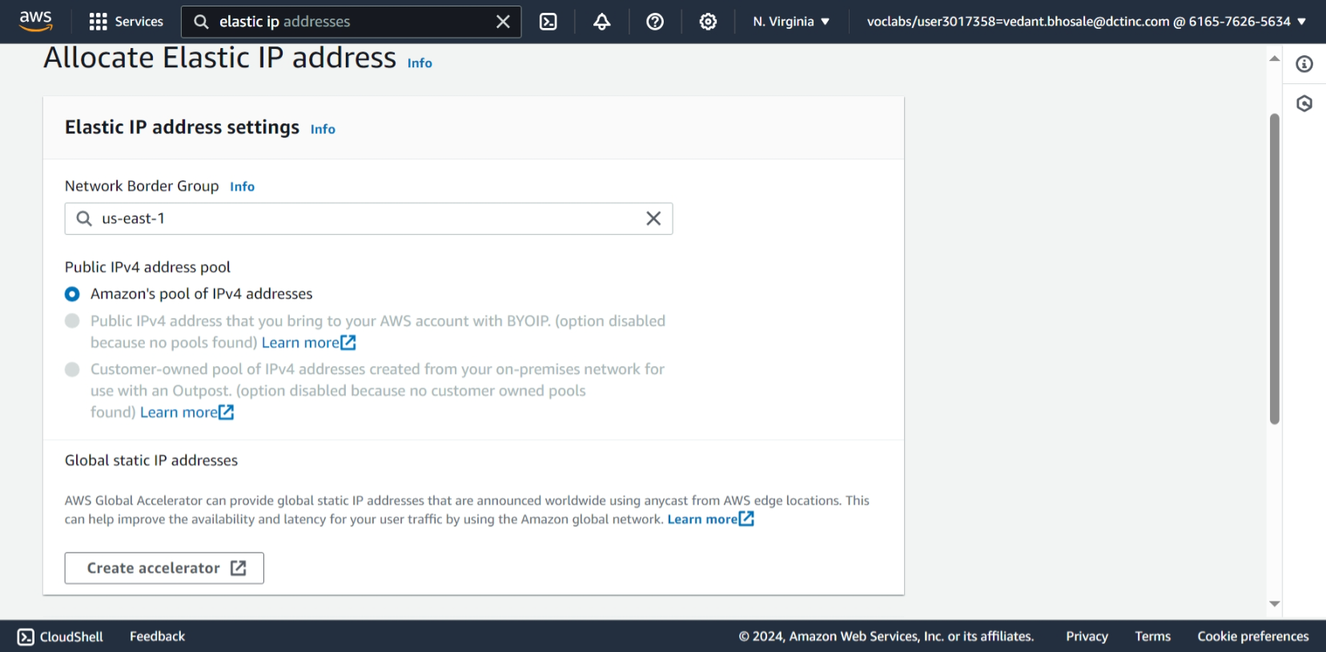

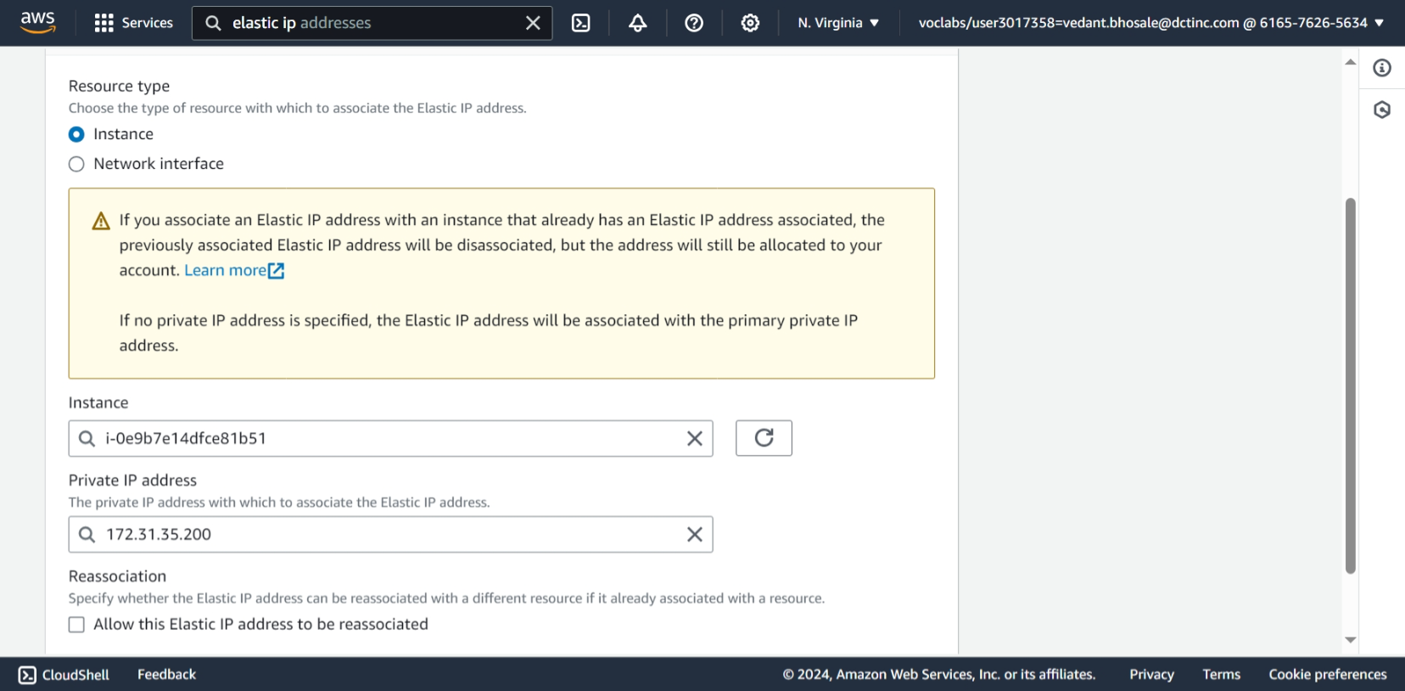

1. Here we see the allocated Elastic IP address

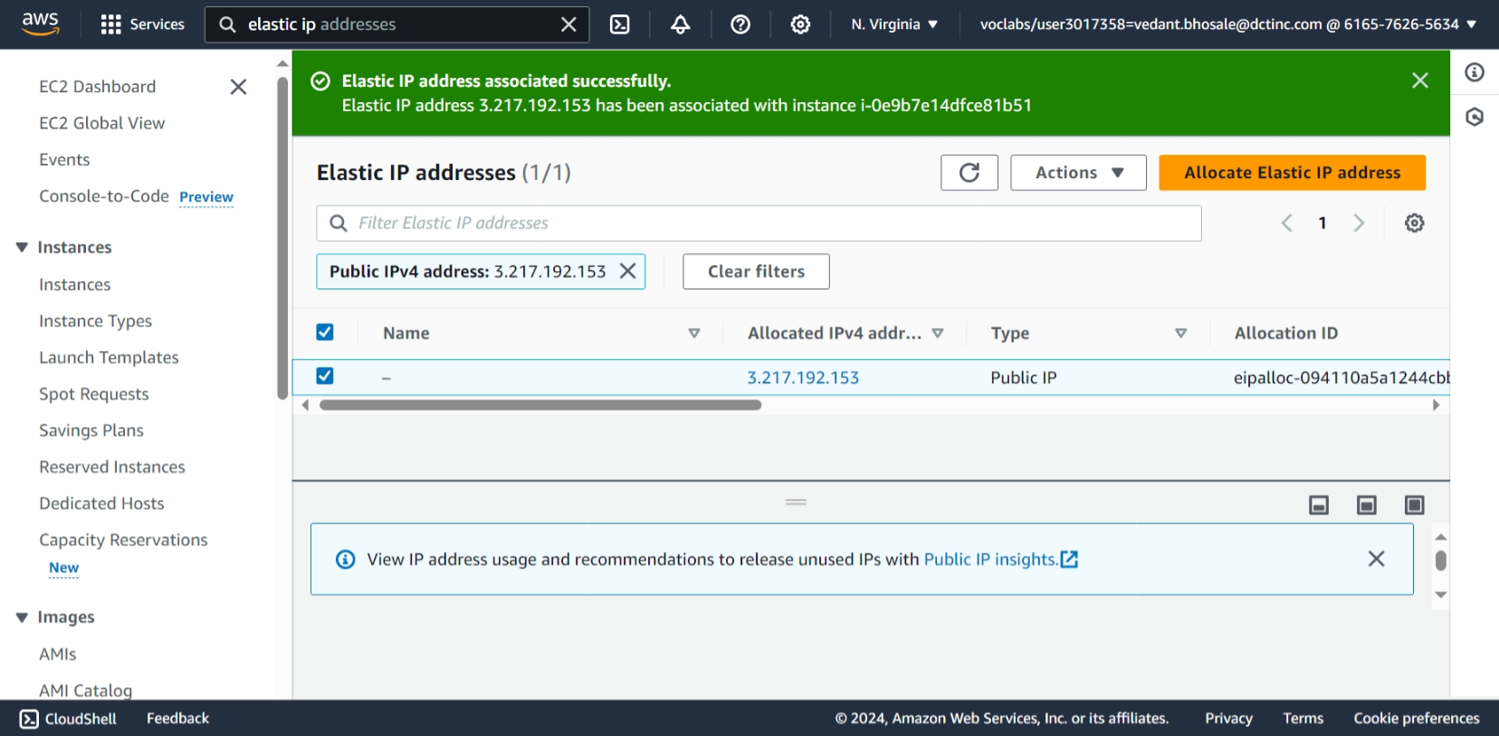

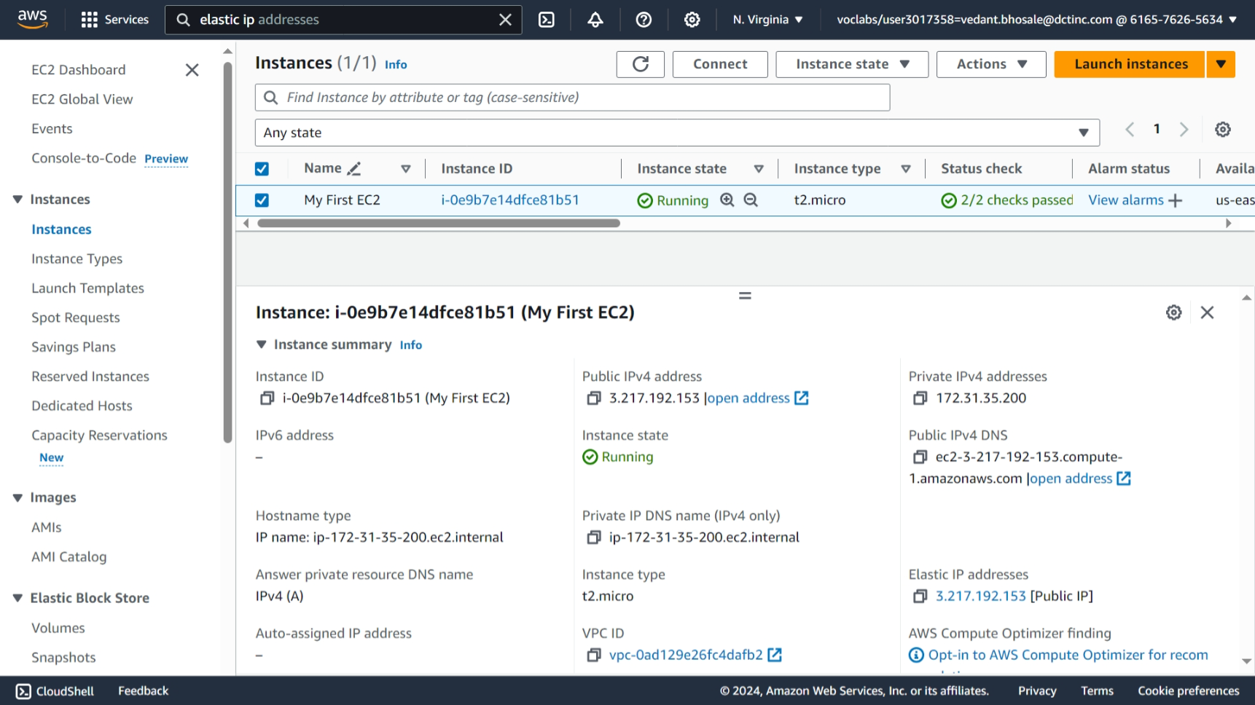

1. Connected to EC2 Instance

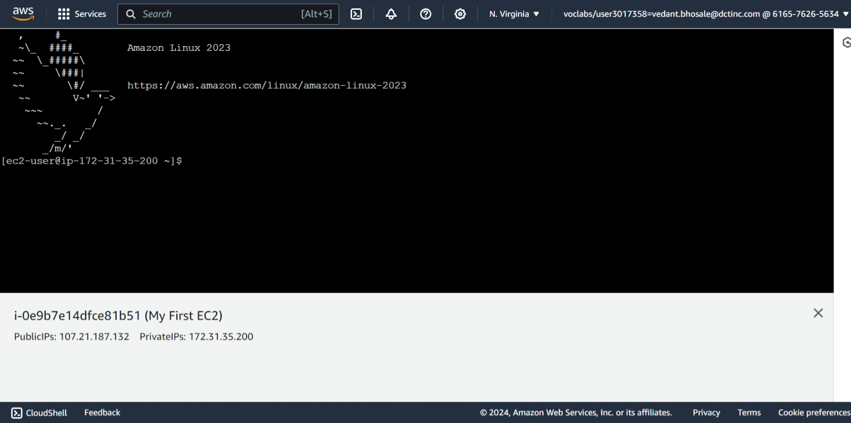

1. Connected to Ec2 instance using ssh

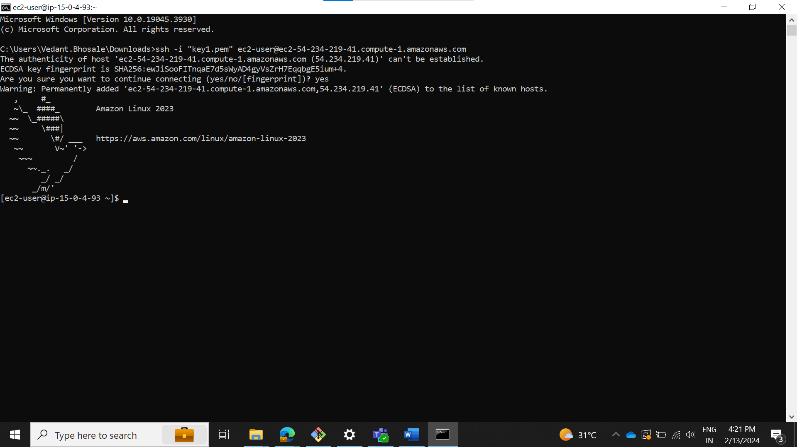

1. **S3 Storage Fundamentals Lab**
   * **Objective**: To gain hands-on experience with Amazon S3 by performing basic storage operations.
   * **Approach**: This lab involves creating an S3 bucket, uploading files to it, and setting up bucket policies for access control. Students will explore the S3 management console, learn about object storage, and understand the concepts of buckets and objects.
   * **Goal**: Students will understand how to use S3 for storing and managing data, learn about S3 security and permissions, and become familiar with S3's user interface.
2. Click on create bucket

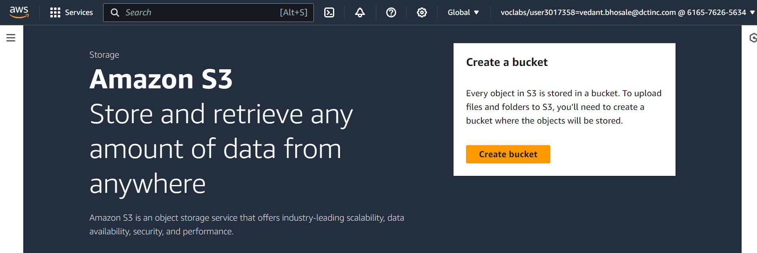

1. In create bucket
   * Give AWS region, bucket type, bucket name
   * Keep ACLs enabled to give public access to uploaded objects
   * Untick Block all public access
   * Click on create bucket.

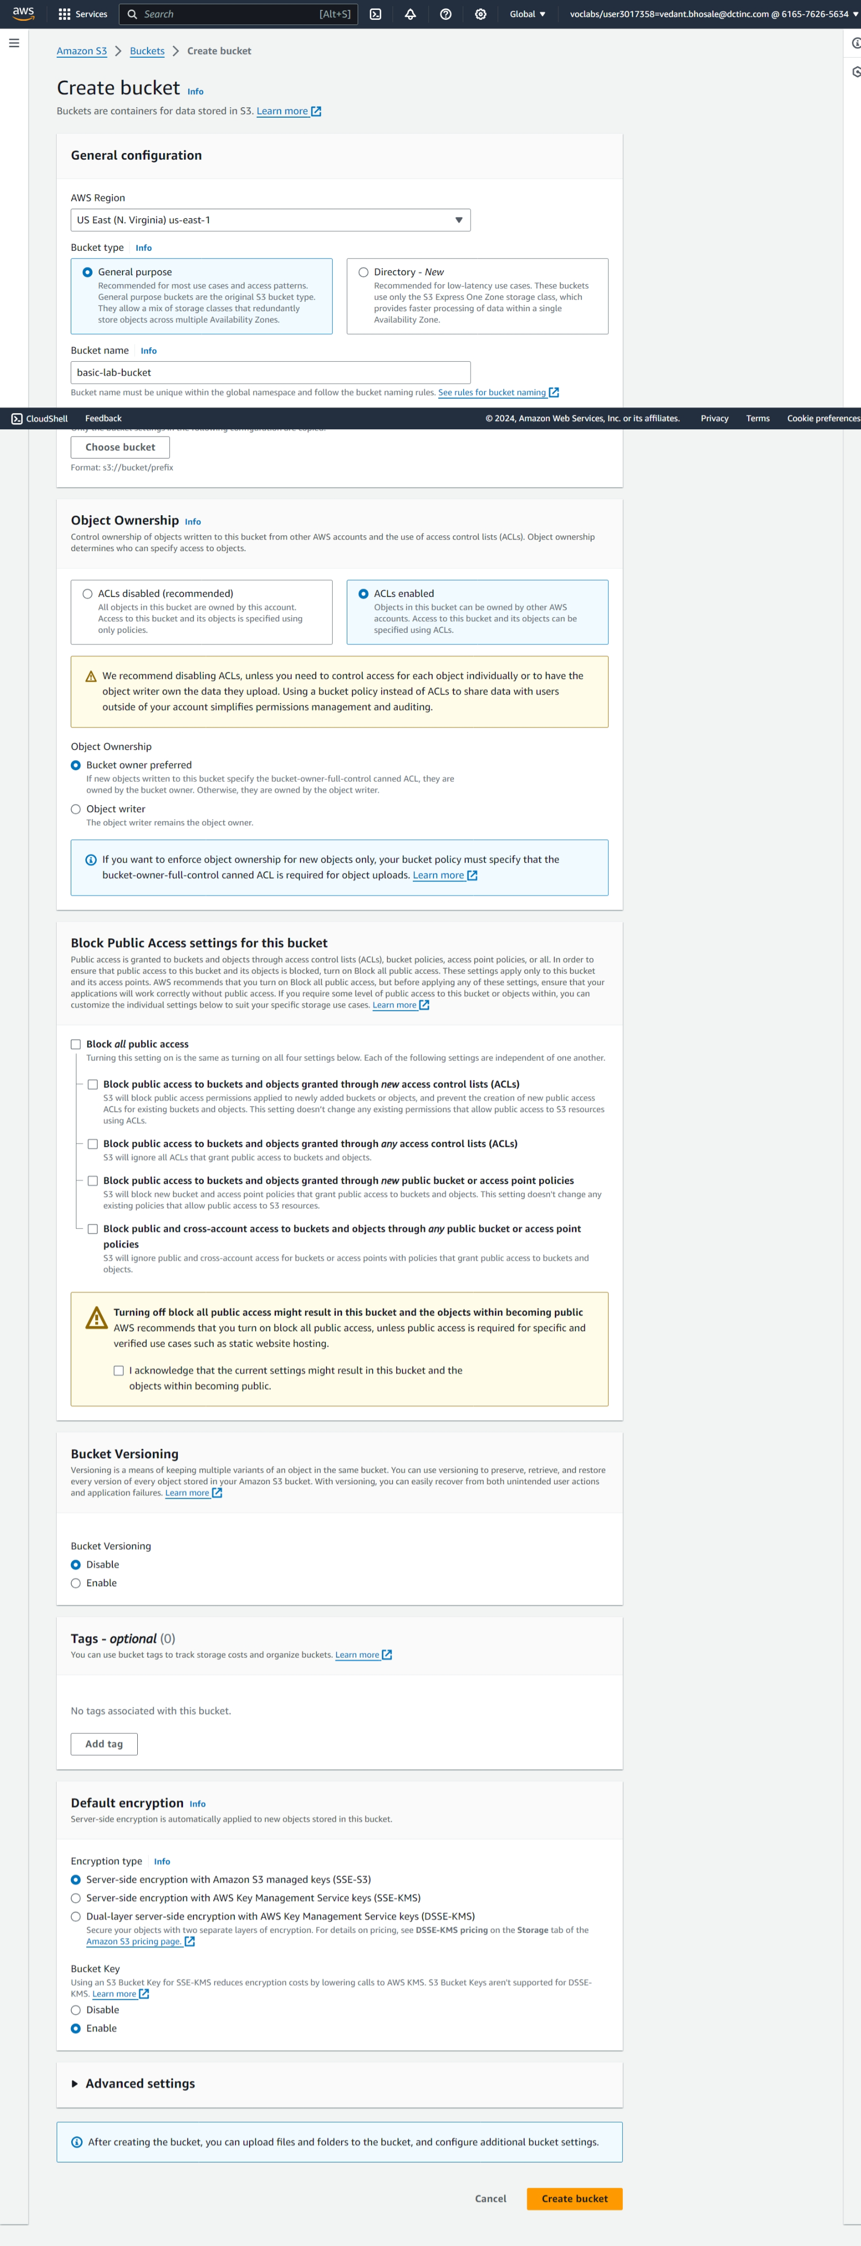

1. Here we can see created bucket

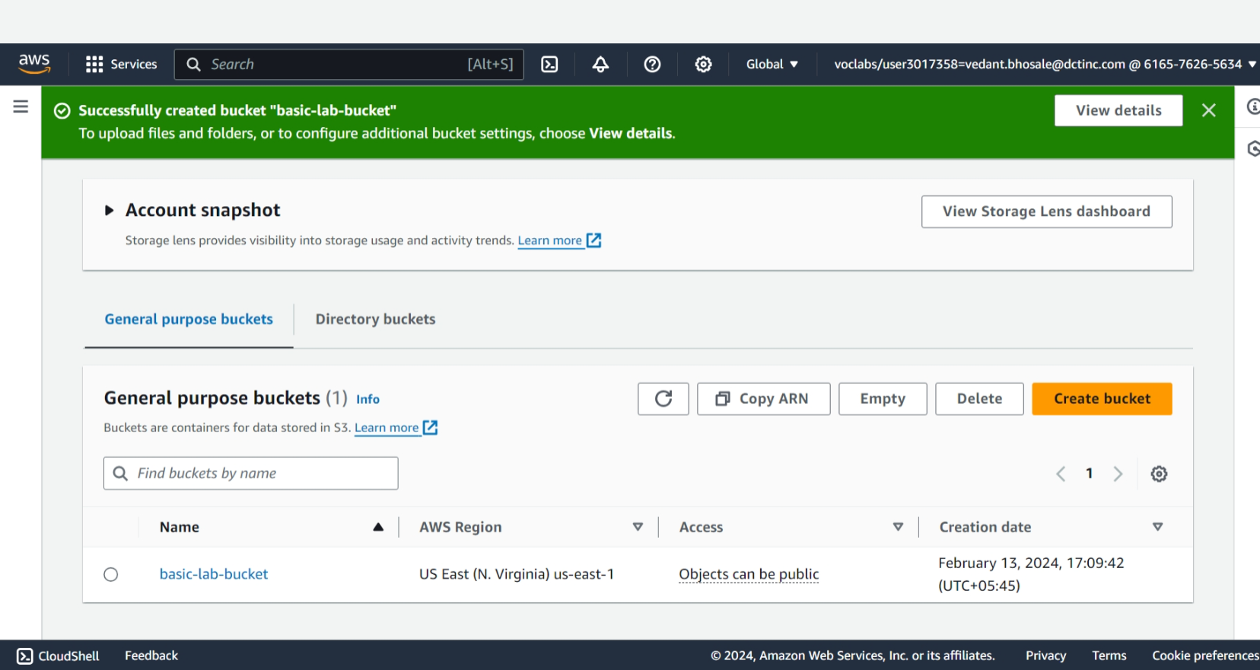

1. To upload files in the bucket click on upload and drag drop the files

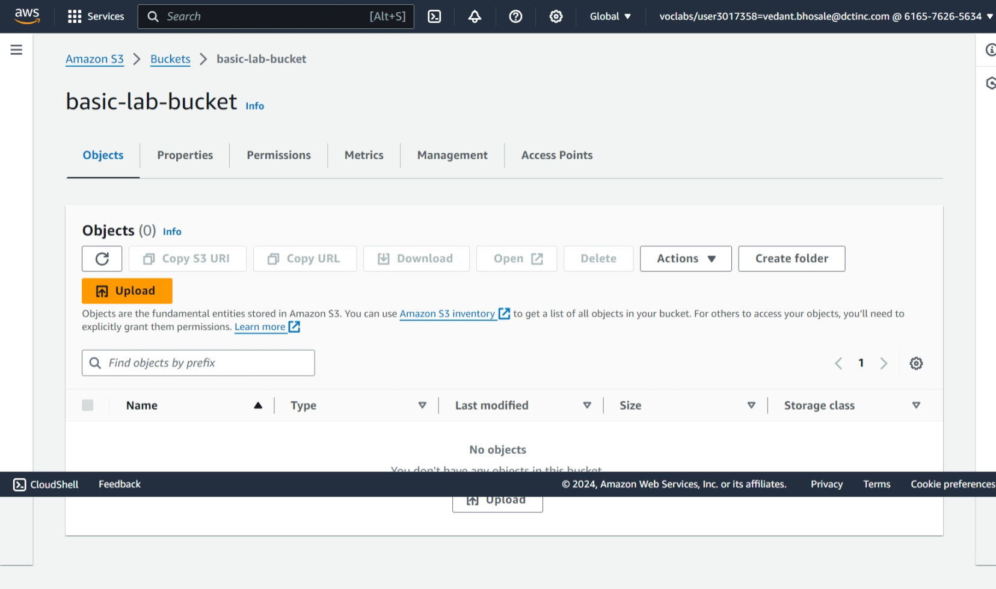

1. Here you can see the upload in successful

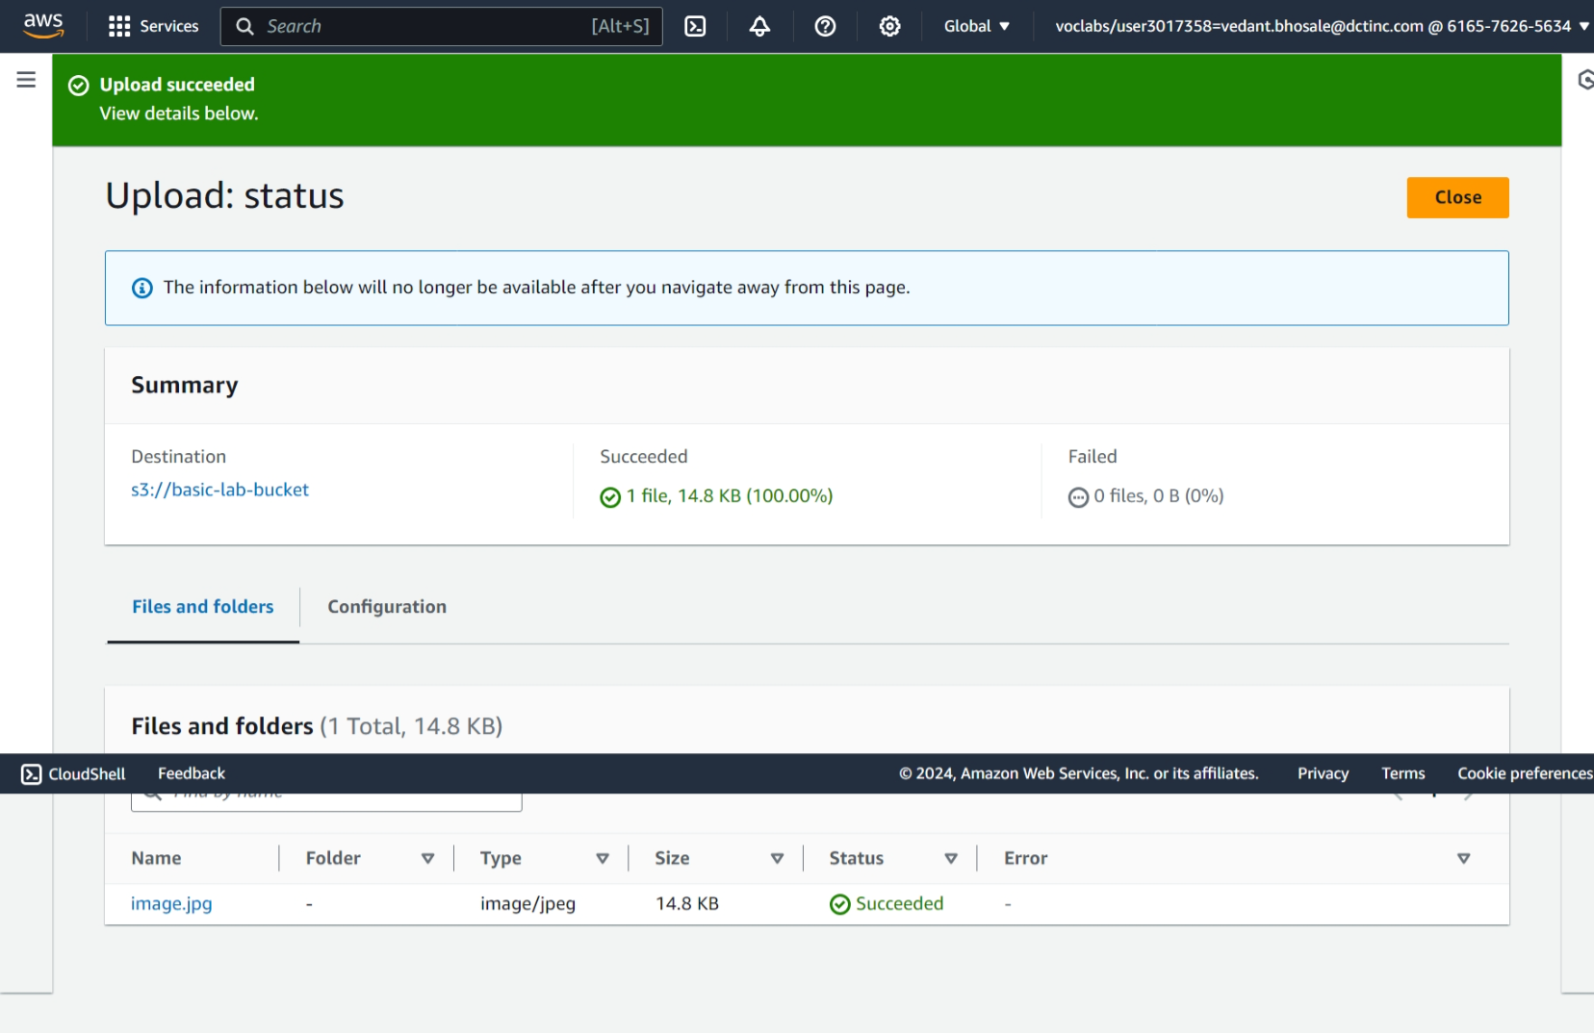

1. To access the image using public URL
   * Go to Object actions
   * Select Make public using ACL

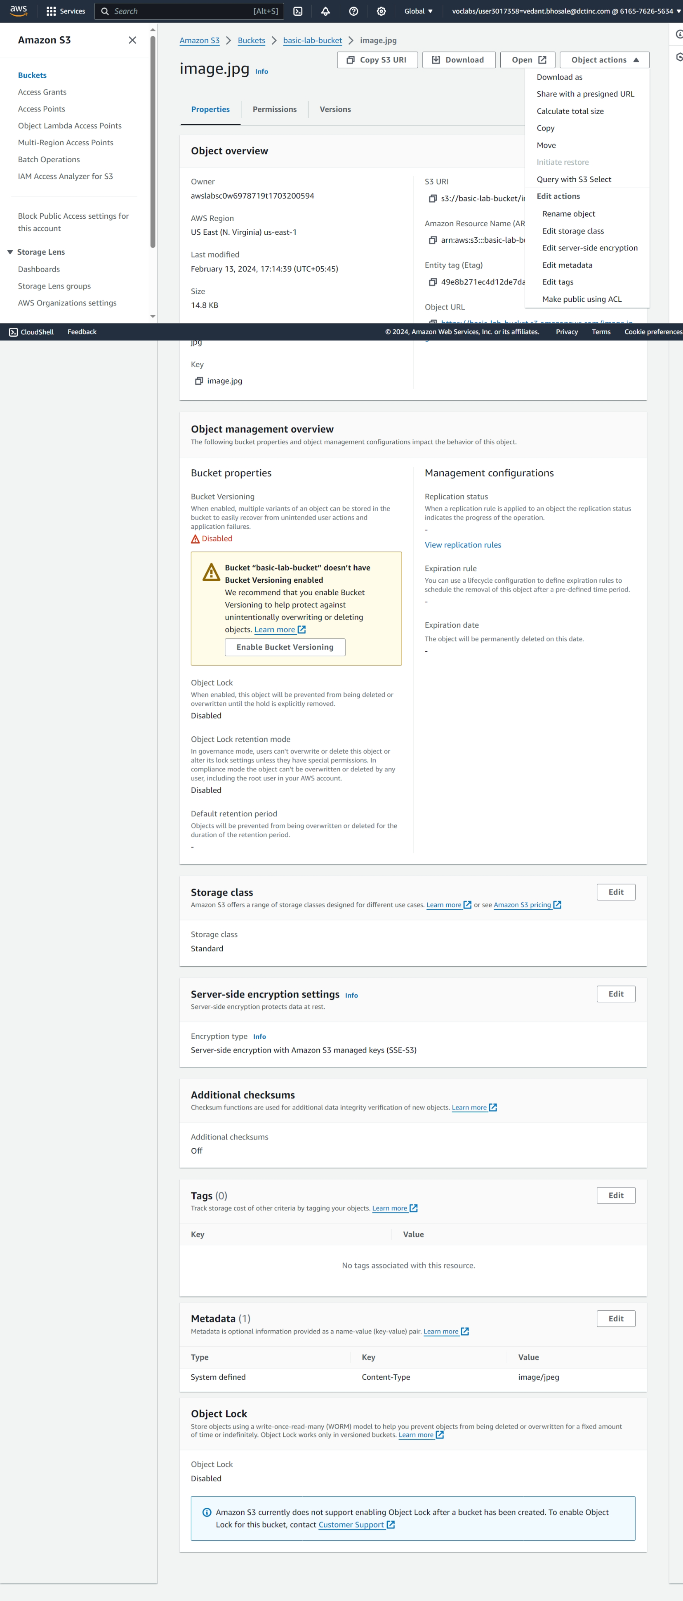

1. Here click on make public

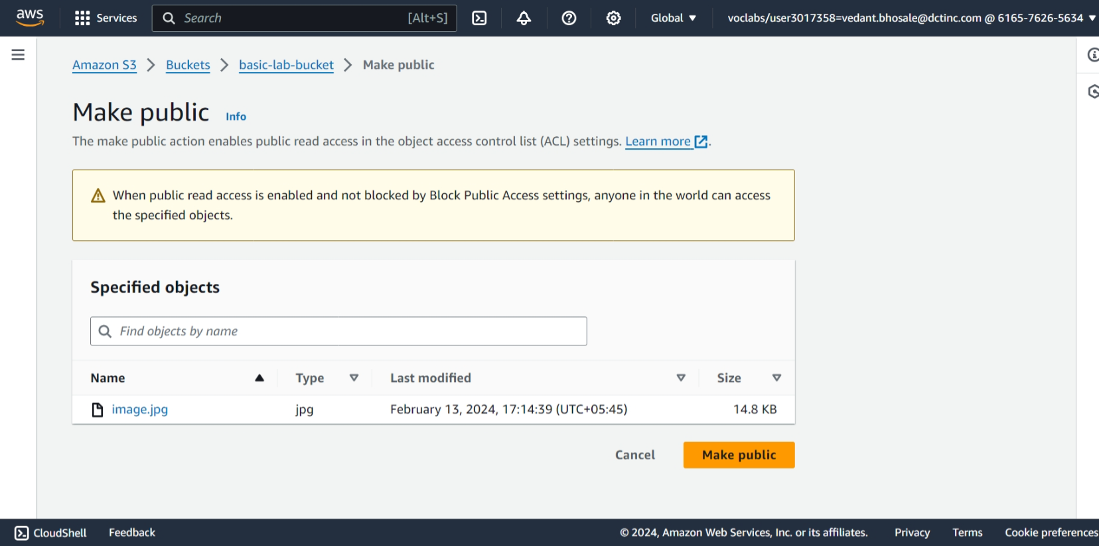

1. Here we can get Object URL

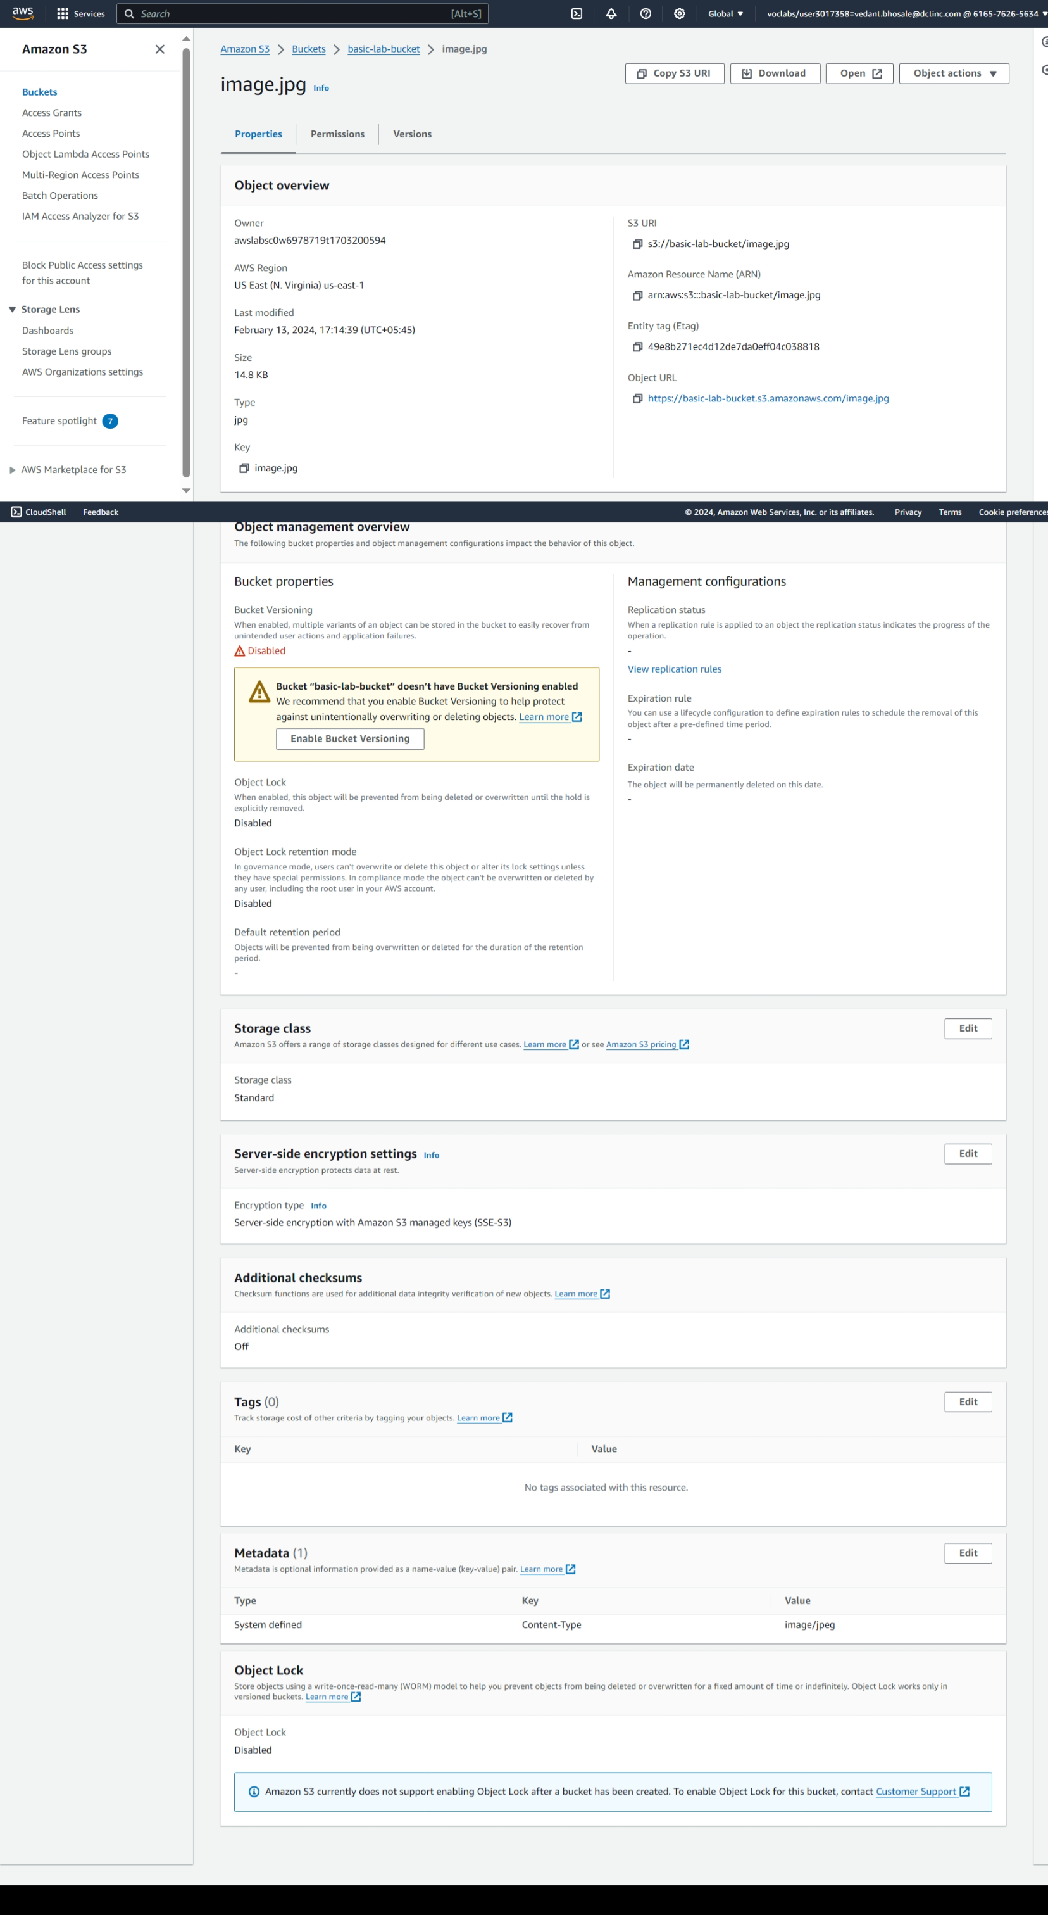

1. Here we can see the image in s3 using Object URL

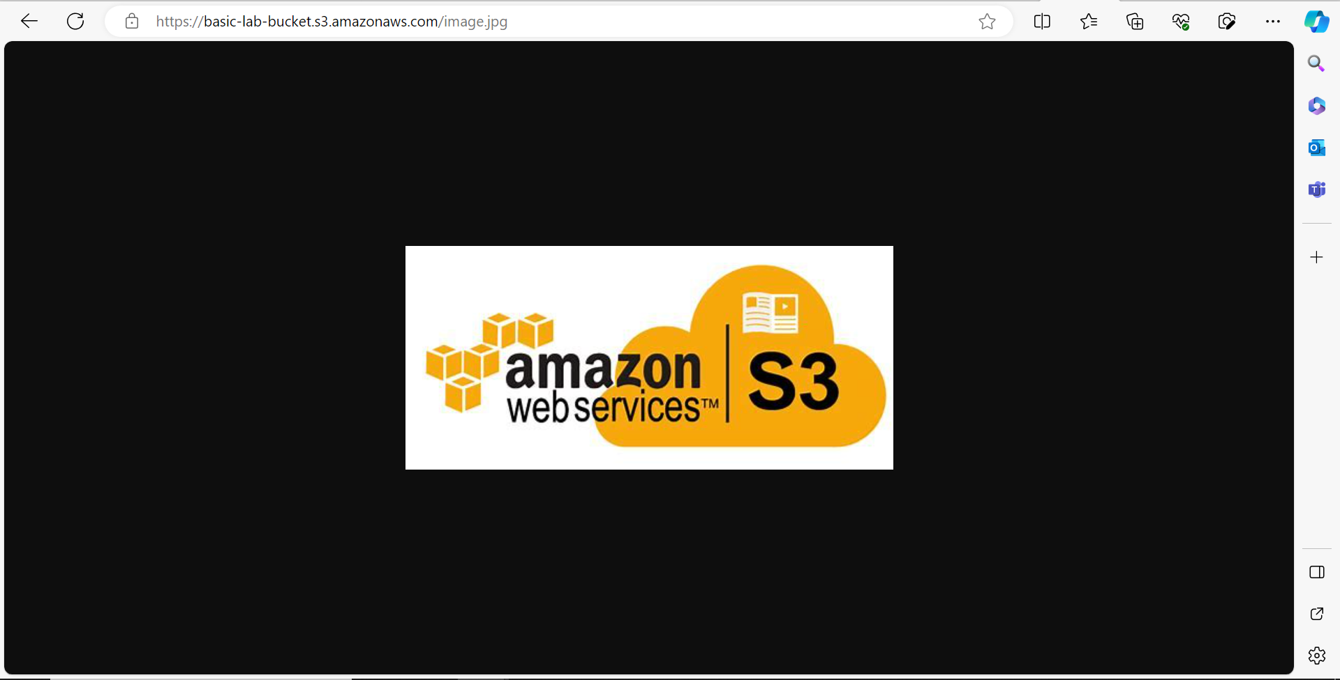

1. **VPC Configuration Lab**
   * **Objective**: To understand the fundamentals of AWS networking through the configuration of a Virtual Private Cloud (VPC).
   * **Approach**: Students will create a new VPC, add subnets, set up an Internet Gateway, and configure route tables. The lab might also include setting up a simple EC2 instance within this VPC to demonstrate how resources are deployed in a custom network environment.
   * **Goal**: By the end of this lab, students should be able to create and configure a VPC, understand subnetting, and the role of route tables and internet gateways in AWS.
2. Click on Create VPC

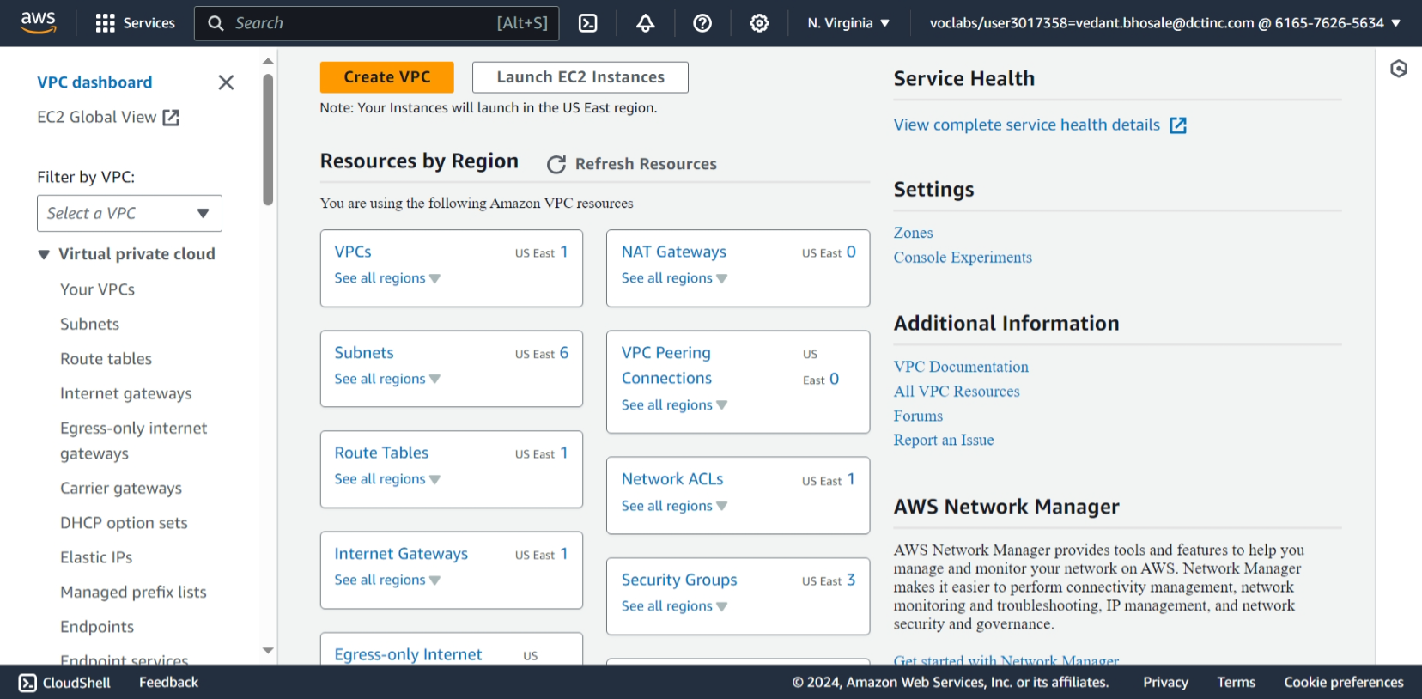

1. Select VPC and more
   * Give IPV4 CIDR Block
   * Give number of availability zones, public subnets, private subnets
   * Give IPs to public and private subnets
   * Click on create VPC .

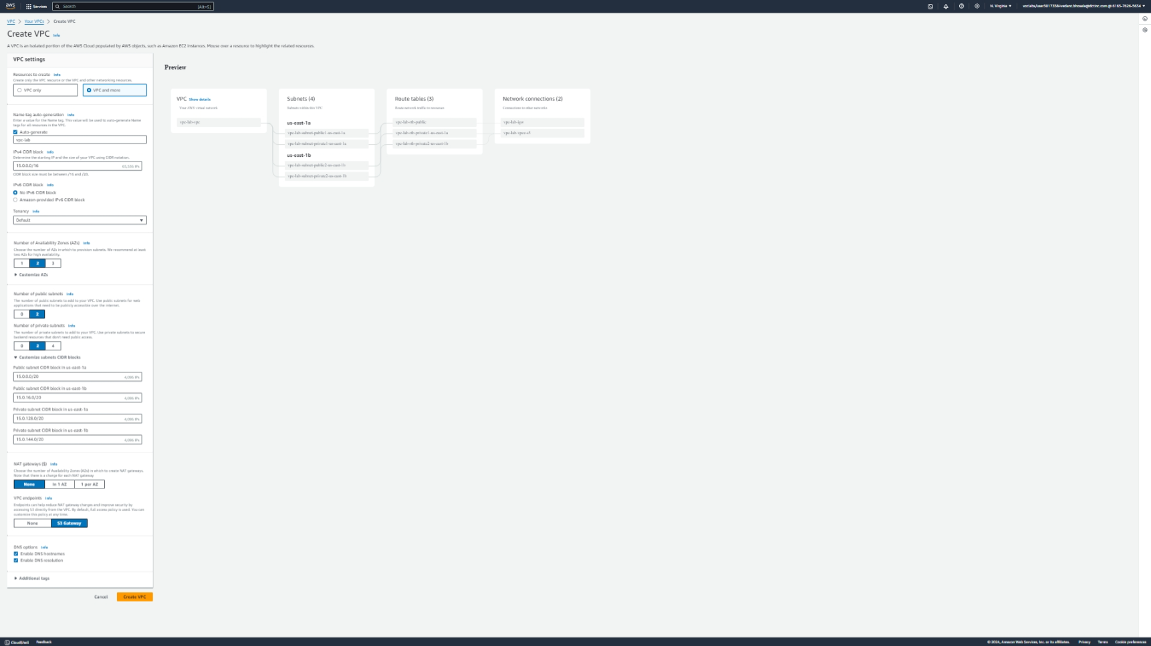

1. Below shows Create VPC workflow

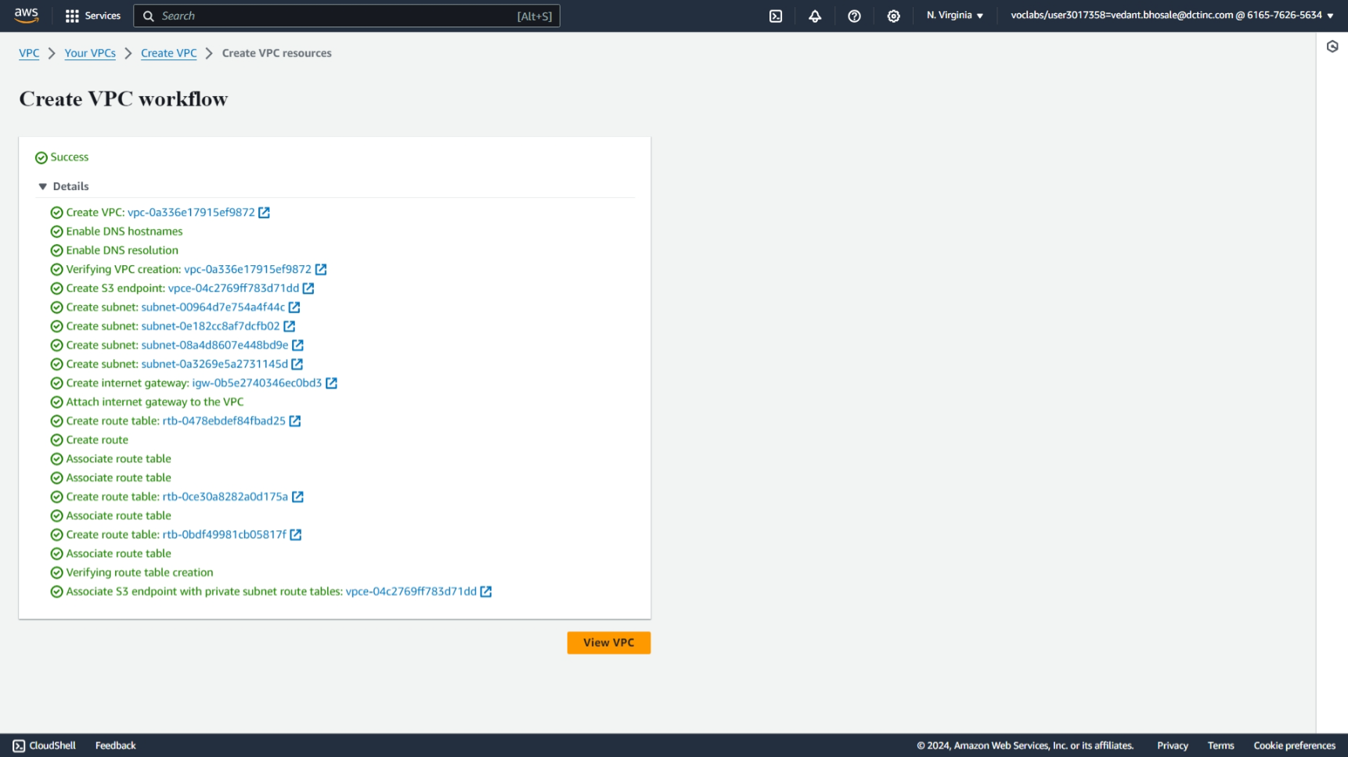

1. Here we can see the VPC created in Your VPCs

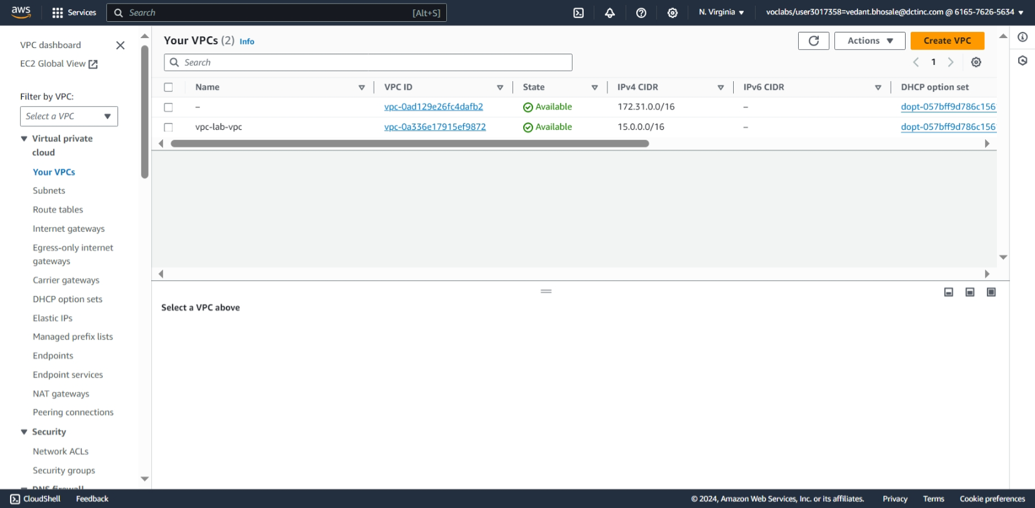

1. here we launch an EC2 Instance in created VPC

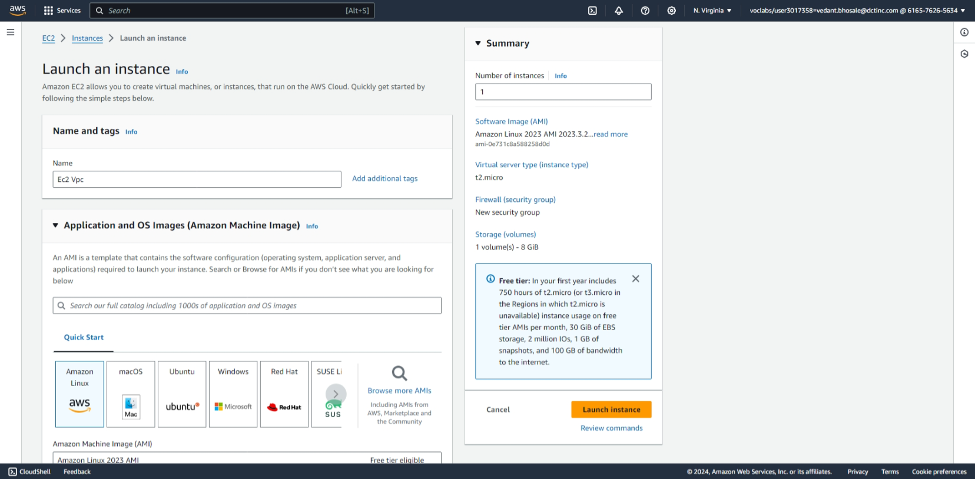

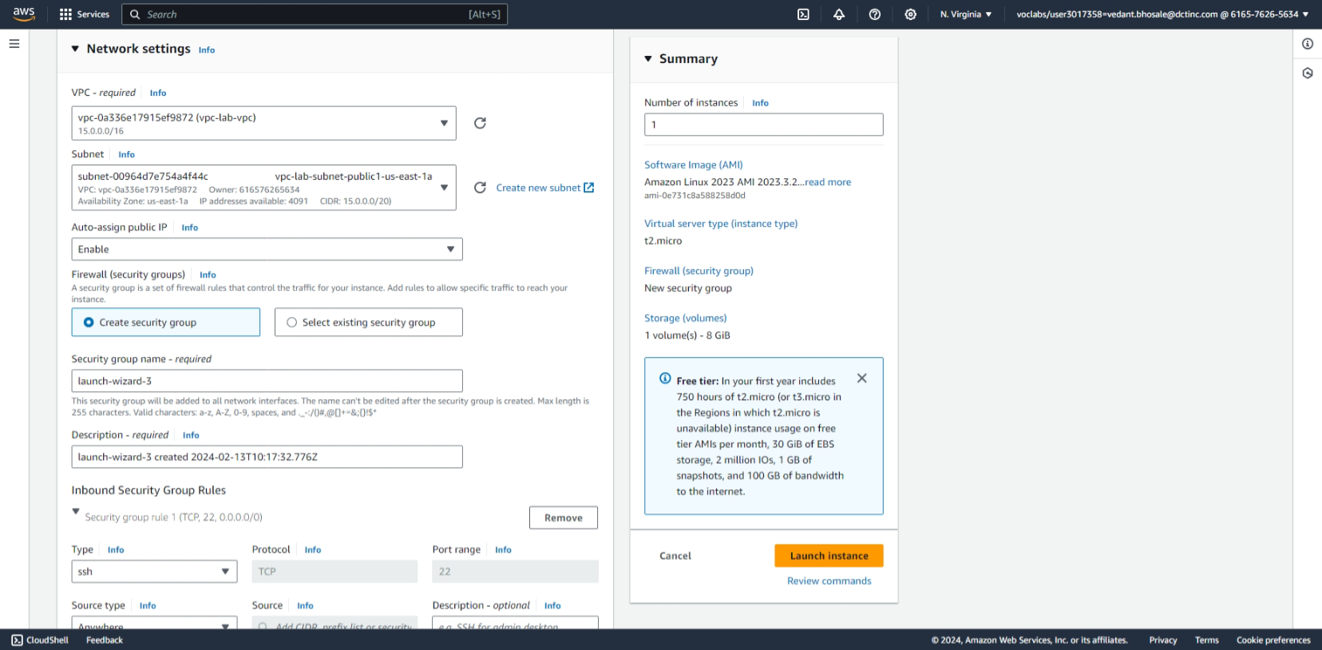

1. here we see the created EC2 Instance

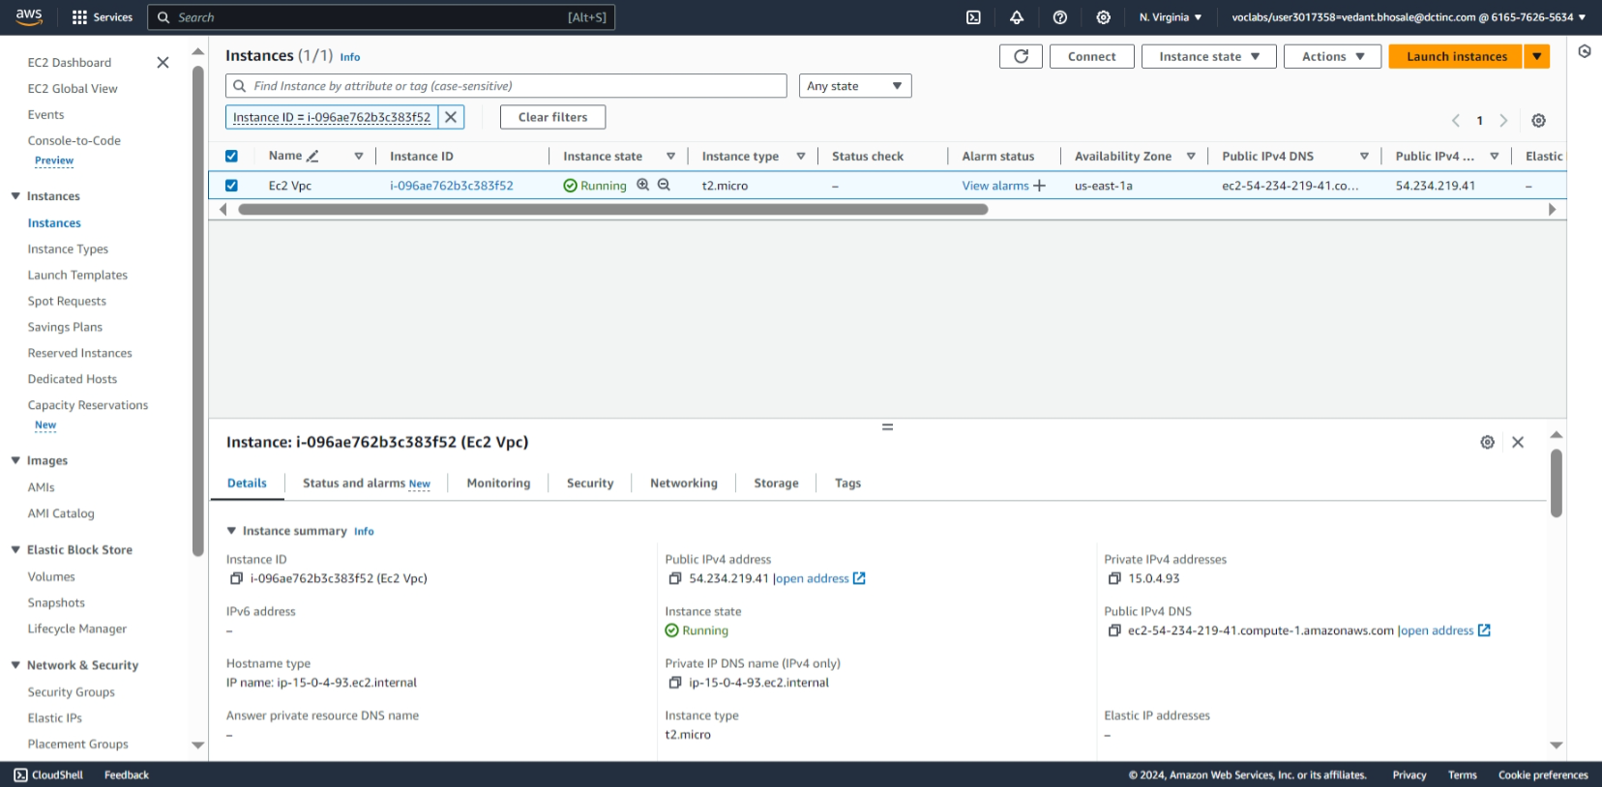

1. connecting the EC2 Instance using ssh

